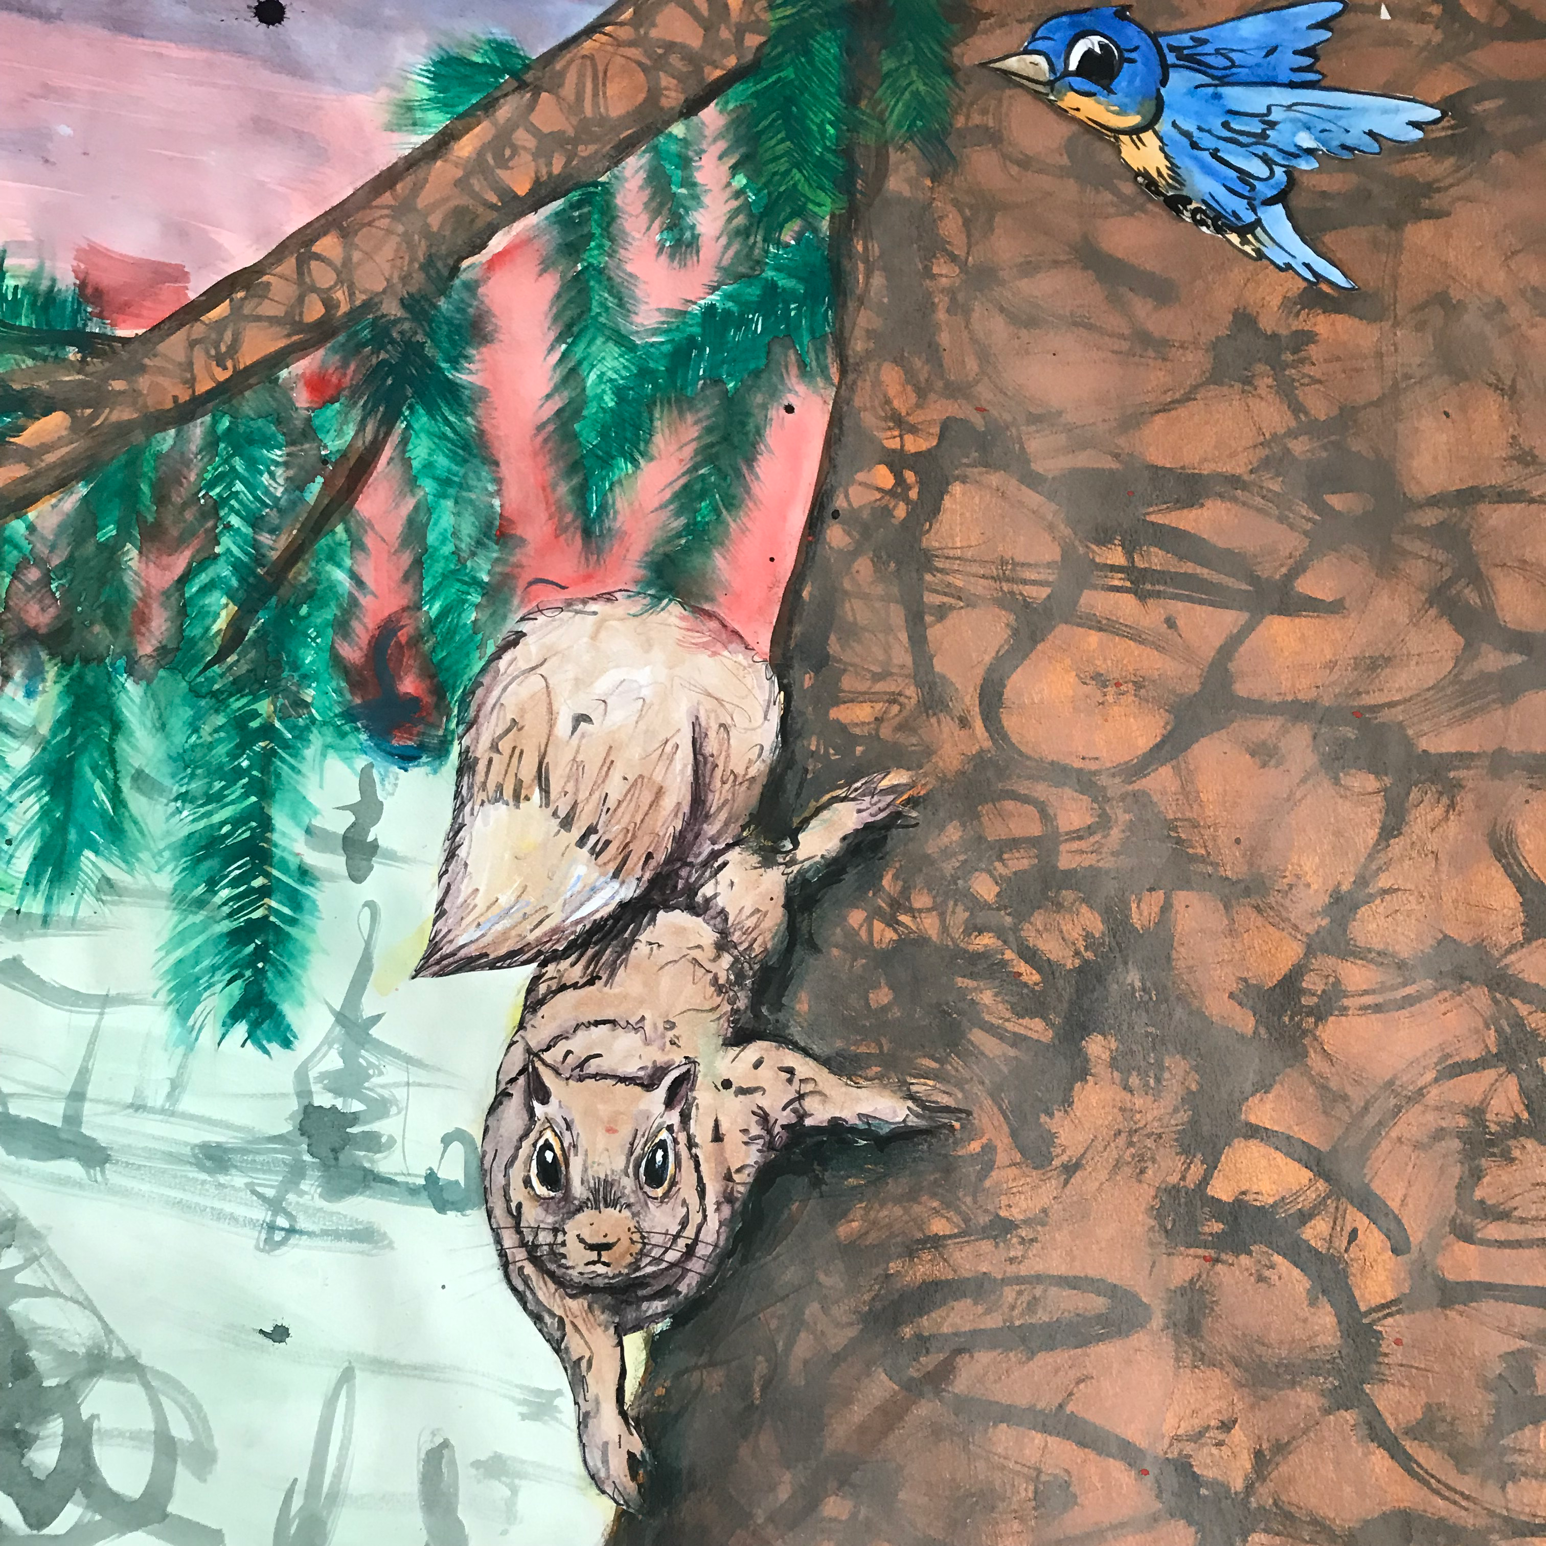
Phil Knoll, A Fine Spring Day, super-scale drawing installation

ICEHOUSE Project Space
34 Upper Main St., Sharon, CT

Opening reception: Sunday, April 28, 4-6pm
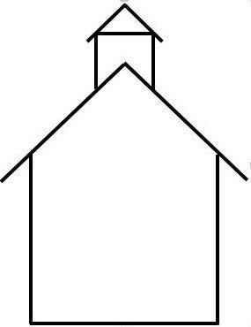
Closing reception and artwork give-away: Saturday, May 18, 4-6pm

ICEHOUSE hours are by appointment only.

Please call KK Kozik at 917 488 8740 or get in touch with Phil at philip.john.knoll@gmail.com

